Question 1: Dental X-Ray Enhancement and Cavity Region Extraction
Scenario and aim: The radiograph is dark, low in contrast and noisy, and a small cavity has almost the same grey level as the enamel and dentine around it. The aim is to make the cavity visible, extract it as a connected region and outline it, without blurring its boundary.

Processing Pipeline and Justification
- Power-law (gamma) transformation. s = c·r^γ with γ ≈ 0.45. The grey levels are crowded at the dark end of the histogram. A γ below 1 expands the dark values and compresses the bright ones, so the enamel, dentine and cavity range is lifted without saturating. It is preferred to the log transform because the exponent can be tuned. The negative transform is only a display aid (cavity appears bright on dark) and adds no contrast of its own.
- Histogram equalisation. Gamma shifts the grey levels but does not spread them. Equalisation maps them through the cumulative histogram so the narrow band is stretched over 0–255, which raises the contrast between the slightly radiolucent cavity and the enamel. It also amplifies quantum noise, so smoothing must come next.
- Edge-preserving spatial smoothing. A 5×5 median filter removes the speckle-like quantum noise without averaging across edges, and a bilateral filter then smooths flat regions while keeping the intensity step at the cavity border. A mean or Gaussian filter would blur that step and reduce the contrast of small cavities.
- Tooth isolation by Otsu thresholding. Otsu’s threshold maximises the between-class variance and separates tooth from bone and background. Hole filling and erosion keep the crown interior and exclude the borders and thin roots, where false dark regions appear.
- Region growing for the cavity. The seed is the pixel with the highest local contrast (local median minus smoothed value) inside the crown. Neighbours join the region if their grey level is within a tolerance of the seed. Region growing is preferred to one global threshold because the cavity’s grey level overlaps other dark structures, and it guarantees a connected region.
- Edge detection to outline the cavity. The Canny detector (Gaussian smoothing, gradient, non-maximum suppression, hysteresis thresholding) is applied to the extracted mask and gives a thin, closed outline. It is overlaid in red on the enhanced image for the dentist.
Why this order? The order is enhance, denoise, segment, outline. Smoothing follows equalisation because equalisation amplifies noise, and edge detection comes last because derivative operators are very noise-sensitive.
Summary of steps
Step | Technique | Role in the pipeline
1 | Power-law (gamma) transformation | Brighten the dark grey levels
2 | Histogram equalisation | Stretch cavity-to-enamel contrast
3 | Edge-preserving spatial smoothing | Suppress noise, keep the cavity border
4 | Tooth isolation by Otsu thresholding | Separate tooth from background
5 | Region growing for the cavity | Extract a connected cavity region
6 | Edge detection to outline the cavity | Draw a thin, closed outline

Processing Results for Question 1
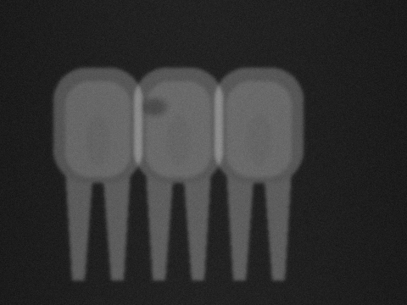  Fig. 1.1: Original dark, low-contrast X-ray | 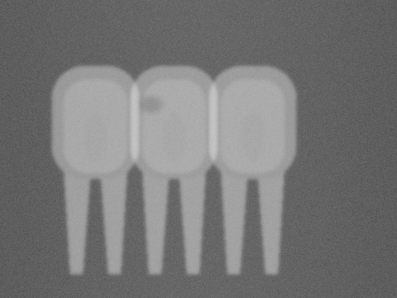  Fig. 1.2: After power-law transform (γ = 0.45)
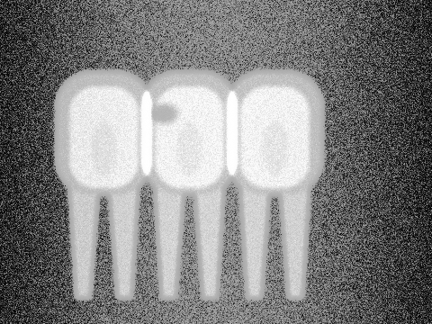  Fig. 1.3: After histogram equalisation | 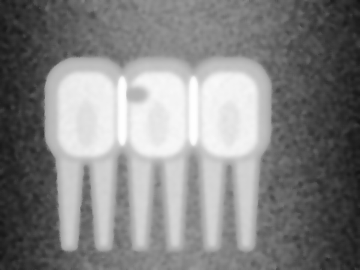  Fig. 1.4: After median + bilateral smoothing
  Fig. 1.5: Extracted cavity (region growing) | 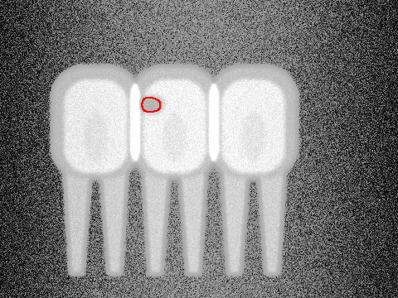  Fig. 1.6: Cavity outline (Canny) on enhanced image
Outcome. The cavity, which is hard to see in the original radiograph, is clearly visible after the grey-level transform and equalisation. Bilateral smoothing suppresses the noise while the cavity border stays sharp, and region growing extracts a single compact region. Canny edge detection then outlines it with a thin closed contour that the dentist can inspect directly.

Question 2: Night-Time Vehicle Number Plate Region Extraction
Scenario and aim. The night-time toll-gate image has very low brightness, bright headlight glare, sensor noise and motion blur. The aim is to enhance the dark regions without letting the glare dominate, restore the character edges, locate the rectangular plate and separate the characters from the plate background.

Processing Pipeline and Justification
- Power-law transformation. γ ≈ 0.45 brightens the dark car body and plate. Because it is a global mapping, it also brightens the headlights, so it cannot control glare on its own. It is used only as the first step.
- Contrast-limited adaptive histogram equalisation (CLAHE). Global equalisation would be dominated by the large dark area and the saturated glare. CLAHE equalises 4×4 tiles separately and clips each histogram, so the plate gets its own local contrast stretch while glare and noise are not over-amplified.
- Median filtering. A 5×5 median filter removes sensor noise, which is impulse-like. Unlike a mean filter it keeps the plate edges sharp, which matters because motion blur has already softened them.
- Sharpening by unsharp masking. g = f + k(f − blur(f)) with k ≈ 0.8 restores the character and plate edges softened by motion blur. It is chosen over a plain Laplacian because the Gaussian blur inside it limits noise amplification. The Laplacian is the alternative, g = f − ∇²f.
- Edge detection, line detection and edge linking. Canny gives the edge map. The probabilistic Hough transform keeps near-horizontal and near-vertical line segments (within 8°), which are typical of a rectangular plate border. A morphological closing with a 17×5 rectangle links the broken edge fragments into closed blobs. The contours are then filtered by aspect ratio (about 2.5–6.5), size and brightness, and the plate rectangle is the one that passes.
- Thresholding of the characters. The plate is cropped, and Otsu thresholding is applied because the crop is bimodal (dark characters on a bright plate). Local thresholding is the fallback for uneven lighting. The output is a clean binary character image for the OCR stage.
Why this order? Brightness is fixed first, then noise and blur are handled, and only then are edges computed, since edge operators fail on dark, noisy input. Thresholding is applied to the cropped plate only, so glare outside the plate cannot affect the threshold.
Summary of steps
Step | Technique | Role in the pipeline
1 | Power-law transformation | Lift the dark plate and car body
2 | Contrast-limited adaptive histogram equalisation (CLAHE) | Local contrast with controlled glare
3 | Median filtering | Remove sensor noise, keep edges
4 | Sharpening by unsharp masking | Restore blurred character edges
5 | Edge detection, line detection and edge linking | Locate the rectangular plate boundary
6 | Thresholding of the characters | Separate characters from the plate

Processing Results for Question 2
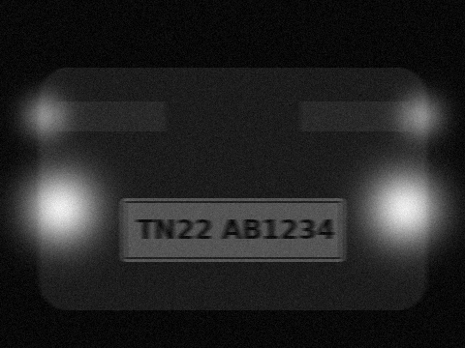  Fig. 2.1: Original night-time image (dark, glare, noise) | 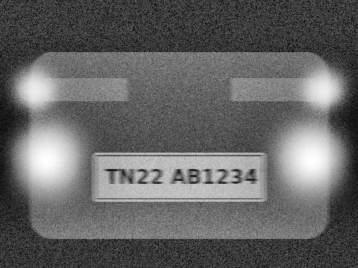  Fig. 2.2: After gamma + CLAHE
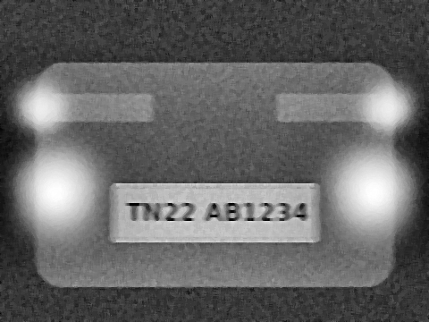  Fig. 2.3: After median + unsharp masking | 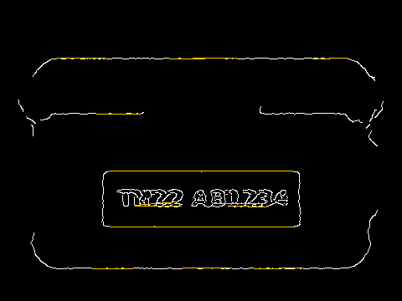  Fig. 2.4: Canny edges with Hough line segments
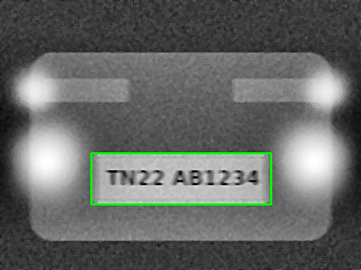  Fig. 2.5: Plate localised by edge linking | 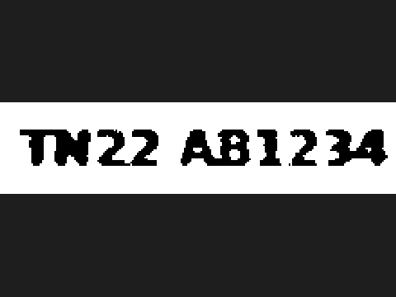  Fig. 2.6: Binary characters after Otsu threshold
Outcome. Gamma correction followed by CLAHE brings out the plate and car body while the glare is kept in check. Median filtering and unsharp masking give clean, sharp character strokes. Edge detection, Hough line detection and edge linking find the rectangular plate border, and thresholding the cropped plate leaves clean black characters ready for recognition.

Question 3: Textile Fabric Defect Detection Using Frequency-Domain Processing
Scenario and aim. A regular weave pattern and periodic lighting noise hide the defects (hole, broken thread, oil stain, knot), and the illumination is uneven across the roll. The aim is to remove the periodic components in the Fourier domain so that only the irregular defects remain, then segment and outline them.

Processing Pipeline and Justification
- Reflect padding and 2-D Fourier transform. The image is mirror-padded so that boundary discontinuities do not cause spectral leakage. The centred log spectrum shows a few isolated bright spikes: the weave fundamental and its harmonics, and the lighting-flicker frequency. Defects, being non-periodic, are spread over many frequencies and form no spikes.
- Notch (band-reject) filtering. Gaussian notch pairs, H = ∏(1 − e^(−D²/2σ²)), are placed symmetrically at every spike found by automatic peak detection. Only these narrow frequencies are removed. A low-pass filter would blur the defects, and a high-pass filter would keep the weave. The Gaussian shape avoids the ringing of an ideal notch.
- Inverse transform and border trimming. After the inverse DFT the weave and the stripes are gone, leaving a flat texture in which holes, knots, stains and thread breaks stand out. The border margin, where filter ringing remains, is discarded.
- Illumination correction and histogram processing. Illumination is multiplicative and varies slowly across the roll. Dividing by a heavy Gaussian estimate (σ = 40) of the background follows the homomorphic idea and flattens it. Histogram equalisation then stretches the remaining contrast.
- Thresholding. A robust deviation score |z| = |I − median| / (1.4826·MAD) is thresholded at 7 after light smoothing. The test is two-sided, so dark defects (holes, stains) and bright defects (knots, thread breaks) are both found. Morphological closing and small-object removal clean the mask.
- Boundary detection. Border following extracts the external contour of each defective region, which is drawn in red to outline the defects for the inspector.
Why frequency-domain processing? Frequency-domain processing is preferred because the weave and the lighting noise are periodic and appear as a few narrow spikes in the spectrum, but cover the whole image in the spatial domain. A spatial filter would need a very large kernel and would blur the defects as well. A notch filter removes exactly those frequencies and leaves the broadband defect energy untouched. The FFT is also fast enough for line-scan inspection.

Summary of steps
Step | Technique | Role in the pipeline
1 | Reflect padding and 2-D Fourier transform | Reveal periodic spikes in the spectrum
2 | Notch (band-reject) filtering | Remove weave and flicker noise
3 | Inverse transform and border trimming | Leave only non-periodic defects
4 | Illumination correction and histogram processing | Flatten the uneven illumination
5 | Thresholding | Segment dark and bright defects
6 | Boundary detection | Outline each defective region

Processing Results for Question 3
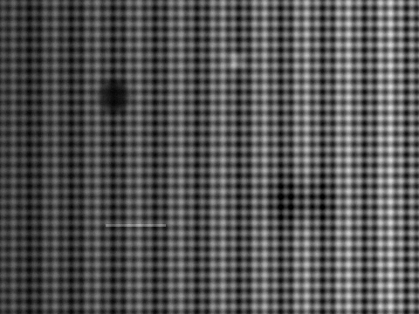  Fig. 3.1: Original fabric (weave, stripes, uneven light) | 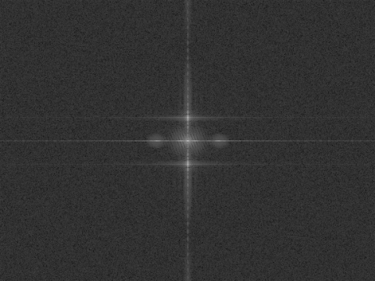  Fig. 3.2: Centred log Fourier spectrum
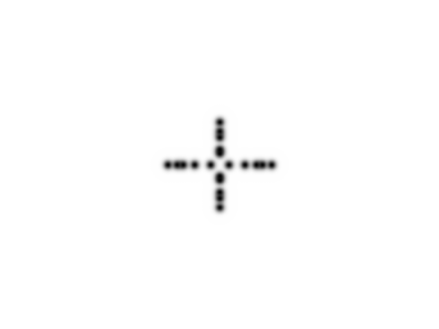  Fig. 3.3: Notch-filter mask H(u,v) | 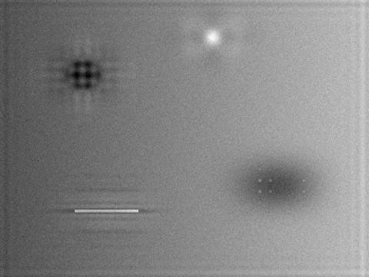  Fig. 3.4: After notch filtering (inverse DFT)
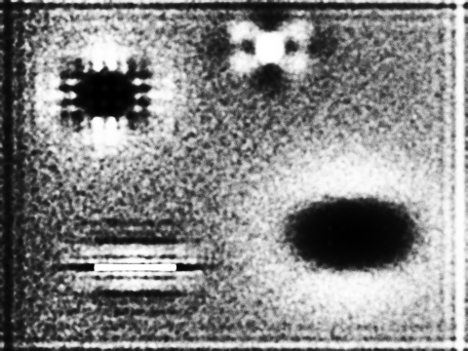  Fig. 3.5: After illumination correction + equalisation | 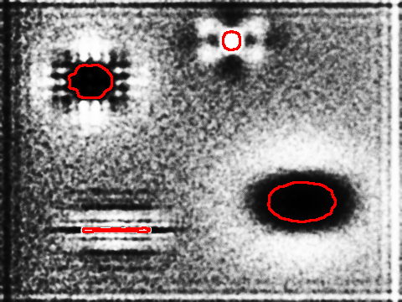  Fig. 3.6: Segmented and outlined defects
Outcome. The notch filter removes the weave and the lighting stripes together, and illumination correction removes the left-to-right brightness change. Thresholding and boundary detection then outline all four defect types: the hole, the knot, the oil stain and the broken thread.

Question 4: Blood Cell Segmentation in Microscopic Images
Scenario and aim. The blood-smear image has uneven staining, poor contrast between cells and background, touching cells and dust. The aim is to enhance the contrast, remove the dust, separate cells from the background, split touching cells and outline each cell.

Processing Pipeline and Justification
- Channel selection and contrast stretching. The green channel gives the best contrast, since stained cells absorb green strongly while the pink background does not. A min–max stretch is applied to it.
- Histogram equalisation. Equalisation spreads the stretched histogram over the full grey range and increases the separation between the dark cells and the bright background. The uneven staining remains (darker corners), which is the reason for choosing an adaptive threshold later.
- Median filtering for noise removal. A 5×5 median filter followed by a light Gaussian removes dust specks. They are smaller than half the window, so the median removes them completely, while cell boundaries are preserved. A mean filter would only smear the dust into grey spots.
- Adaptive thresholding. The threshold is the Gaussian-weighted local mean over a 71×71 window minus an offset. A single global (Otsu) threshold fails here because the stain density varies across the field, and the dark corner would be classed as foreground. Opening, removal of objects under 150 pixels and hole filling (central pallor) follow.
- Region-based segmentation of touching cells. The distance transform is computed, and its local maxima give one marker per cell. Marker-controlled watershed then floods from these markers, which is a form of region growing and splitting. The ridges where the floods meet become the separating lines. Plain connected-component labelling would count a touching pair as one cell.
- Edge and boundary detection. The boundary of every labelled region is traced and overlaid in green on the original image. Each region can then be counted and measured (area, perimeter, circularity), and white cells are told apart by the dark nucleus.
Why this order? Contrast enhancement comes before filtering so the dust is clearly visible to the filter. Filtering comes before thresholding so the dust does not create false regions. Watershed is applied to the binary mask only after thresholding, and boundary tracing is last, once every cell has its own label.
Summary of steps
Step | Technique | Role in the pipeline
1 | Channel selection and contrast stretching | Maximise cell-to-background contrast
2 | Histogram equalisation | Spread the grey levels
3 | Median filtering for noise removal | Remove dust, keep cell boundaries
4 | Adaptive thresholding | Separate cells despite uneven stain
5 | Region-based segmentation of touching cells | Split touching cells
6 | Edge and boundary detection | Outline and count individual cells

Processing Results for Question 4
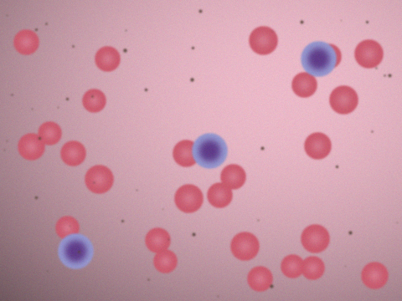  Fig. 4.1: Original smear (uneven stain, dust) | 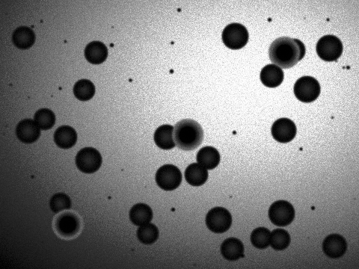  Fig. 4.2: Green channel after equalisation
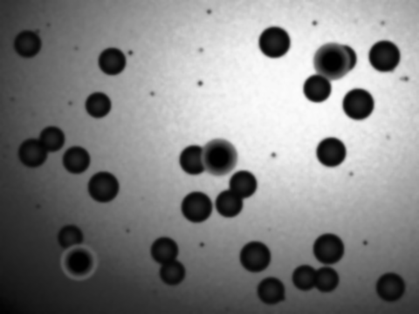  Fig. 4.3: After median + Gaussian filtering | 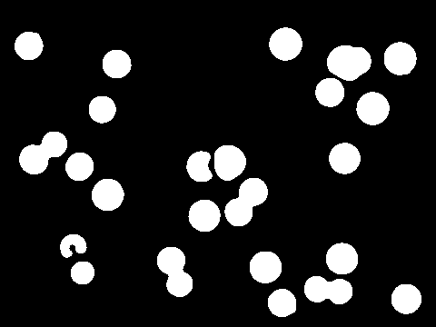  Fig. 4.4: Adaptive threshold + clean-up
  Fig. 4.5: Watershed labels (touching cells split) | 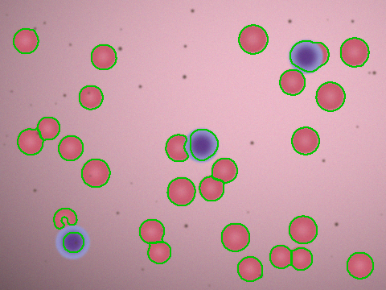  Fig. 4.6: Individual cell boundaries on original
Outcome. Equalising the green channel makes the cells clearly darker than the background. Median filtering removes the dust, and adaptive thresholding copes with the uneven staining. Watershed splits the touching cells into separate regions, and the traced boundaries give accurate regions for counting and measuring red and white blood cells.

Question 5: Text Extraction from Degraded Historical Documents
Scenario and aim. The scanned manuscript has yellowed paper, ink bleed-through from the reverse side, stains, faded strokes and uneven lighting. The aim is to improve the contrast of the faded ink, clean the page, binarise it correctly and locate text lines and words for the recogniser.

Processing Pipeline and Justification
- Grey-level transformation and CLAHE. The page is converted to greyscale and a power-law transform (γ = 1.3) darkens the mid-tones, which emphasises the ink. CLAHE (6×6 tiles, clip 3) then raises the contrast of the faded strokes. It is used rather than global equalisation because the lighting and the fading both vary across the page.
- Background flattening. A 41×41 median filter estimates the paper background (yellowing, shadows, stains). The strokes are thin, so the median ignores them. Dividing the page by this estimate removes the slowly varying background and brightens the paper to a uniform level.
- Median smoothing. A 3×3 median filter removes speckle noise and the fine texture of the paper while keeping stroke edges. A Gaussian blur would soften the thin pen strokes.
- Sharpening by unsharp masking. g = f + k(f − blur(f)) with k ≈ 0.9 strengthens the pen strokes and makes faded ink darker than the faint bleed-through, which becomes relatively lighter.
- Global versus local thresholding. Otsu’s global method uses one threshold from the whole-page histogram. The stains and shadows appear as large black blobs, and the bleed-through is picked up as text. Local Sauvola thresholding (31×31 window, k = 0.2) computes the threshold from the local mean and standard deviation. In flat background areas the threshold lies below the paper level, so no false foreground appears. Local thresholding is therefore the better choice, and it is used.
- Edge and boundary detection of lines and words. The binary text is dilated horizontally (90×3 element) so each line merges into one blob, and border following traces these contours as line boxes (green). Inside each line a smaller dilation (6×3) merges letters into words, giving word boxes (red). The edge map (Sobel or Canny) can feed the same step.
Why this order? Enhancement and background removal come first because thresholding depends on a uniform background. Sharpening comes after smoothing so that noise is not amplified. Line and word detection comes last because it needs a clean binary image.
Summary of steps
Step | Technique | Role in the pipeline
1 | Grey-level transformation and CLAHE | Boost the contrast of faded ink
2 | Background flattening | Remove yellowing, shadows and stains
3 | Median smoothing | Remove speckle, keep strokes
4 | Sharpening by unsharp masking | Strengthen the pen strokes
5 | Global versus local thresholding | Separate text from background
6 | Edge and boundary detection of lines and words | Find text lines and word regions

Processing Results for Question 5
  Fig. 5.1: Original page (yellowed, stained, bleed-through) |   Fig. 5.2: After gamma + CLAHE
  Fig. 5.3: After flattening, median + unsharp mask | 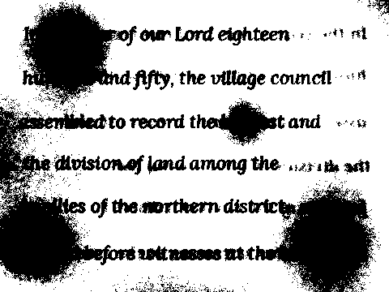  Fig. 5.4: Global Otsu threshold (fails on stains)
  Fig. 5.5: Local Sauvola threshold (clean text) |   Fig. 5.6: Text lines (green) and word regions (red)
Outcome. Global Otsu thresholding fails on this page because the stains and shadows produce large black areas. The local threshold, applied after background flattening, cleanly separates the pen strokes. The line and word boxes give the handwriting recogniser well-defined text regions.

